**WELCOME**

**THIRUVALLUVAR COLLEGE,PAPANASAM.**

**DEPARTMENT OF MATHEMATICS**

**DATA ANALYTICS WITH TABLEAU**

**TOPIC: VISUALIZATIONS TOOL FOR ELECTRIC VEHICLES CHARGE AND RANGE ANALYSIS.**

TEAM MEMBERS

* **M.MARI AJEETHA**
* **P. RAJAKUMARI**
* **M.PETCHIAMMAL**
* **K.HARNI**

**VISUALIZATION TOOL FOR ELECTRIC VEHICLE CHARGE AND RANGE ANALYSIS**

**1.INTRODUCTION**

**1.1OVERVIEW**

**An EV is a shortened acronym for an electric vehicle. EVs are vehicles that are either partially or fully powered on electric power. Electric vehicles have low running costs as they have less moving parts for maintaining and also very environmentally friendly as they use little or no fossil fuels (petrol or diesel).**

**Around 1832, Robert Anderson develops the first crude electric vehicle, but it isn't until the 1870s or later that electric cars become practical. Pictured here is an electric vehicle built by an English inventor in 1884. Photo courtesy of the Smithsonian.**

**EVs will help reduce harmful urban air pollution associated with conventional vehicles, which is the bane of most Indian cities.**

1.2 purpose

**1. Use of this project.**

**Electric vehicles use electricity to charge their batteries instead of using fossil fuels like petrol or diesel. Electric vehicles are more efficient, and that combined with the electricity cost means that charging an electric vehicle is cheaper than filling petrol or diesel for your travel requirements.**

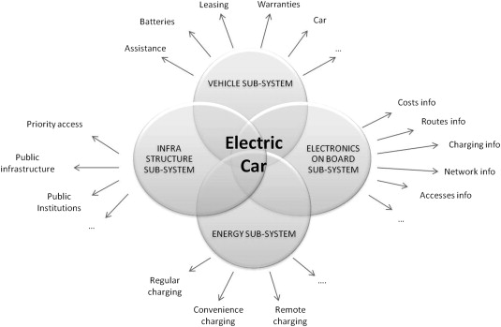

**2. Problem Definition and Design thinking**

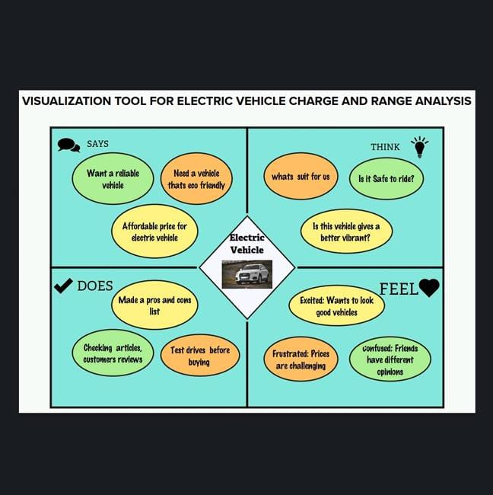What are the problems you have faced with Electric vehicle and how to improve it?

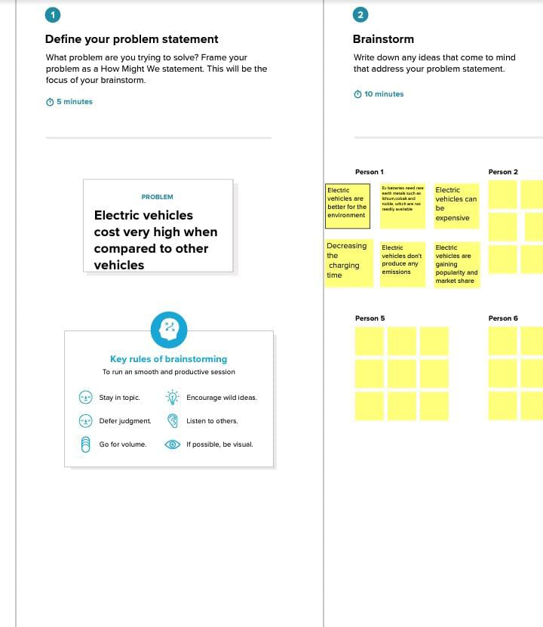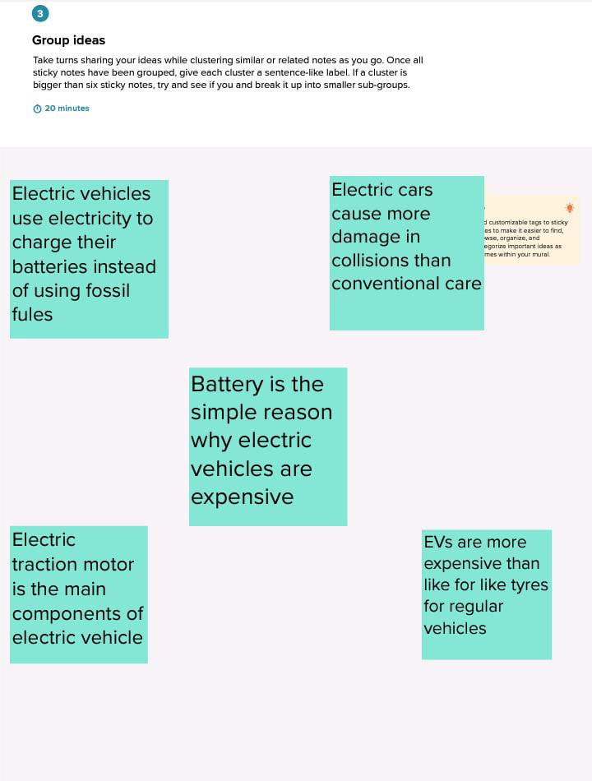



TABLEAU



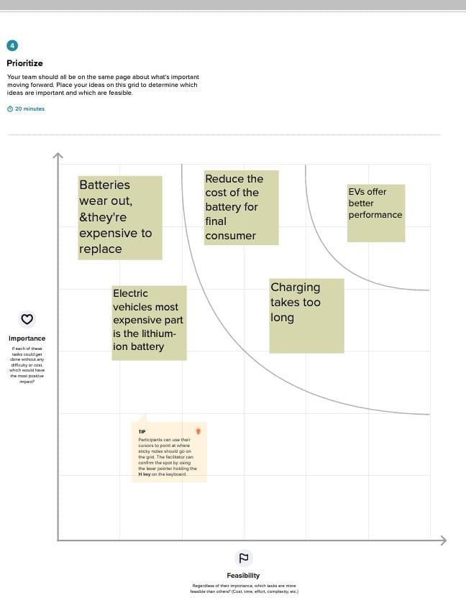

**3. Results:**





ss













**4. ADVANTAGES AND DISADVANTAGES OF THE ELECTRIC VEHICLES**

**VF**

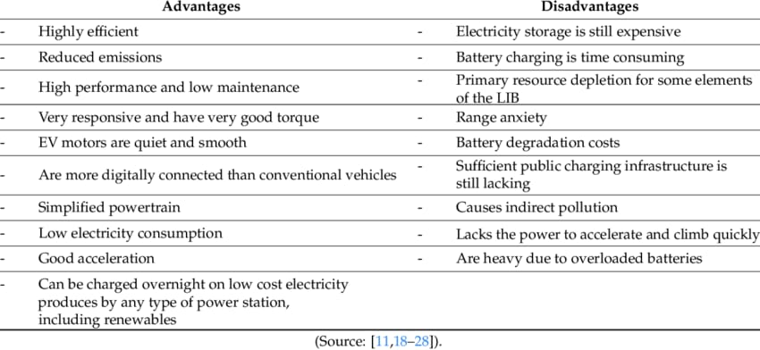

**Electric cars are energy efficient**

Energy efficiency refers to the amount of energy from the fuel source that is converted into actual energy for powering the wheels of a vehicle. AEVS like offerings from Tesla are far more efficient than conventional gas-powered vehicles: AEV batteries convert 59 to 62 percent of energy into vehicle movement while gas powered vehicles only convert between 17 and 21 percent. This means that charging an AEV's battery puts more towards actually powering the vehicle than filling a gas tank.

**Electric cars reduce emissions**

**Emissions and carbon footprint reduction, including reduced usage of fuel, is another pro for all-electric vehicles. Because they rely on a rechargeable battery, driving an electric car does not create any tailpipe emissions, which are a major source of pollution in the United States. In addition, the rechargeable battery means much less money spent on fuel, meaning all energy can be sourced domestically (and often through renewable energy resources such as solar panel systems).**

**Improving battery technology in today's light-duty AEVs means they can drive 100 miles while consuming only 25 to 40 kilowatt-hours (kWh) of electricity. Assuming that your electric car can travel three miles per kWh, the electric vehicle can travel about 43 miles for $1.00. By comparison, if we assume that gas costs $2.50 per gallon, an average gasoline vehicle with a fuel efficiency of 22 miles per gallon will only be able to travel 10 miles for the same price. The distance traveled for a fuel cost of $1.00 is nearly four times as far with an electric vehicle.**

**Electric cars perform well and don't need much maintenance**

All-electric vehicles are also high performance vehicles whose motors are not only quiet and smooth but require less maintenance than internal combustion engines such as an oil change. The driving experience can also be fun because AEV motors react quickly, making them responsive with good torque. AEVS are overall newer than their gas powered counterparts and are often more digitally connected with charging stations, providing options such as controlling charging from an app.

**Disadvantages of electric cars**

**Electric cars can travel less distance**

AEVS on average have a shorter range than gas-powered cars. Most models ranging between 60 and 120 miles per charge and some luxury models reaching ranges of 300 miles per charge. For comparison, gas powered vehicles will average around 300 miles on a full tank of gas, and more fuel efficient vehicles getting much higher driving ranges. This may be an issue when looking at AEVs if you frequently take long trips. Availability of charging stations can make AEVS less suitable for activities like road trips.

**Electric cars can take a long time to recharge**

Fueling an all-electric car can also be an issue. Fully recharging the battery pack with a Level 1 or Level 2 charger can take up to eighty hours, and even fast charging stations take 30 minutes to charge to 80 percent capacity. Electric car drivers have to plan more carefully. because running out of power can't be solved by a quick stop at the gas pump.

**Electric cars can be expensive**

Electric vehicles (EVS) usually have a higher price tag upfront, though you can save money owning an EV over time since there is generally less maintenance on an EV and it's less expensive to charge than fuel with gas. Also, while battery packs are more expensive in EVs than conventional vehicles, they last a significant amount of time and come with 8-10 year warranties. So you're not likely to have to pay out of pocket for a replacement. EVs also have federal incentives available as well as sometimes state-specific incentives to help reduce the initial purchase price. More and more automakers than ever are offering EVs. including BMW, Hyundai and Chevrolet.

**5. APPLICATIONS**

Among all of the challenges faced by the EV industry, the most prominently reported problems are low mileage of the vehicles, higher costs, lack of service centers, unawareness about maintenance and servicing, unclear policies, supply chain problems, and insufficient charging stations

**6. Conclusion:**

After doing this project, we have realised the Challenges faced with Electric vehicles and more about Electric vehicle

Moreover, EV vehicle is better than petrol cars as a point of us after doing this project

**ELECTRIC CARS ANALYTICS DASHBOARD**

**DASHBOARD OVERVIEW**

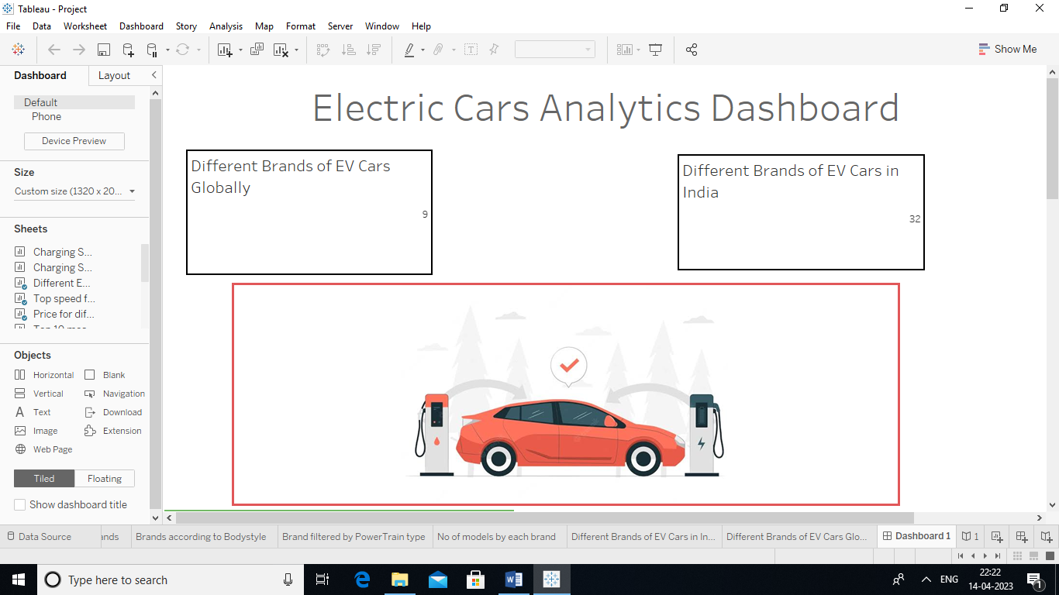



**DS**

**STORY OF ELECTRIC CARS IN INDIA**

STORY OVERVIEW





**7. FUTURE SCOPE;**

**The Indian electric vehicle market was worth USD 1,434.04 million in 2021, and it is predicted to grow to USD 15,397.19 million by 2027, at a CAGR of 47.09% during the forecast period (2022-2027).**

**The Indian automobile industry is the world's fifth biggest, and it is anticipated to become the third largest by 2030. According to the India Energy Storage Alliance (IESA), the Indian EV market would develop at a 36% CAGR.**

**As India's population grows and demand for automobiles increases,**

**reliance on conventional energy supplies is no longer a viable option, as**

**the country imports over 80% of its crude oil.**

**By 2030, NITI Aayog expects to reach 70% EV market penetration for all commercial vehicles, 30% for private vehicles, 40% for buses, and 80% for two and three-wheelers. This is consistent to reach net zero carbon emissions by 2070.**

**THANKYOU**